***Library Rush GDD***

Contents

Game Overview 2

Design Goals 2

Goal #1 2

Goal #2 2

What is the game? 2

Where does the game take place? 2

Who do I control? 2

Feature Set 2

General Features 2

Gameplay Features 2

Game Engine 3

Overview 3

The Game World 3

Overview 3

Key Locations 3

World Layout 3

Characters 4

Overview 4

Player Character 4

Guests 4

User Interface 4

Overview 4

In-Game Display 4

Main Menu 4

Pause Menu 5

Settings Menu 5

Music and Sounds 5

Music 5

Sound Effect List 5

Single Player Experience 5

Overview 5

Progression 5

Hours of Gameplay 5

Victory Conditions 5

Misc. 6

# Game Overview

## Design Goals

### Goal #1

Produce a library themed game that can be used as a promotional tool, presenting libraries in an unexpected and non-traditional way.

### Goal #2

To create a game which will engage with people who may not have visited or used a library for some time and may have an outdated perception of what libraries are and do.

## What is the game?

A skill and time management game where players must return all books to their correct shelfs in a library before running out of time. Players must balance this with additional tasks such as helping guests who are also using the library.

## Where does the game take place?

The game will take place in a modern-day library.

## Who do I control?

The player controls a library assistant robot who manages the organisation of the library.

# Feature Set

## General Features

* 2D Graphics
* Time Management
* AI Pathfinding
* Particle Effects

## Gameplay Features

* 2D Top Down character movement
* Return all books to shelfs before time runs out
* Balance returning books with handling guest tasks
* Attempt to complete each level as quickly as possible

# Game Engine

## Overview

The game engine used in this project will be Unity3D 2019.4.12f1, the latest supported version of the Unity game engine. The engine has both 2D and 3D capabilities, making it useable for this project and all features are well documented in case of any issues.

# The Game World

## Overview

* As in actual libraries the game world will be split into key sections with their own purpose.
* Sections in the game will be designed to reflect their real-world use
* Sections will determine the players activity in the area:
  + Seating will be where majority of guest tasks take place
  + Shelf section will be where player returns books or collects for a task
  + Computer area may generate unique guest tasks

## Key Locations

* Seating Area
* Shelf Section
* Computer Area

# World Layout

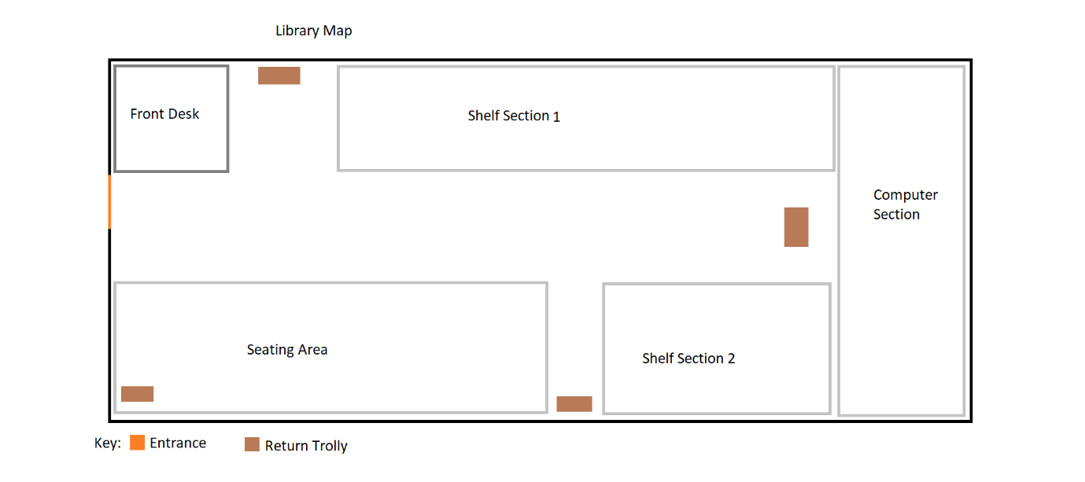

# Characters

## Overview

The game will feature 2 main types of characters: Player and guests.

## Player Character

The Player character is what the player controls when navigating the level. Player characters have a speed to move at and an inventory size which dictates how many books the player can carry around the level.

Player Stats

|  |  |
| --- | --- |
| Stat | Value |
| Move Speed | 20 |
| Inventory Size | 3 |

## Guests

The Guest characters serve to add an extra challenge to the gameplay. They spawn in waves at random intervals between a minimum and maximum time gap if there is a seat available for the guest to occupy. Guests will then move to this seat and have a random chance to create a task for the player. Tasks will involve collecting a specific genre of book and delivering it to the guest within a limited time. Failure to do so too many times will result in a game over.

Guest Stats

|  |  |
| --- | --- |
| Stat | Value |
| Move Speed | 7.0f |
| Task Chance | Dependant on level difficulty (0-20) |
| Number of tasks | Dependant on level difficulty (1-3) |

# User Interface

## Overview

The games User Interface will take 2 main forms, menu’s and the In-Game display.

## In-Game Display

The In-Game display will be responsible for ensuring the player has all the key information they need to play and enjoy the game. This will include:

* Genre of books held
* Zones for depositing books
* Guest Tasks
* Guest Locations for those with tasks
* Time remaining to empty trolleys
* Number of books in trolleys to return

## Main Menu

* Will contain a level select screen, access to the settings menu, Clear save data button and Quit button

## Pause Menu

* Will contain Resume button, access to Settings menu, return to menu button and Quit button

## Settings Menu

* Will allow users to change:
  + Change Resolution
  + Toggle Fullscreen
  + Change Sound Volume
  + Change Music Volume
  + Reset Values

# Music and Sounds

## Music

* Main Menu Music
* In-game music

## Sound Effect List

* Book Collection
* Book Return
* Guest task gain
* Guest task complete
* Button press

# Single Player Experience

## Overview

The key component of the player experience is a mastery of the core gameplay loop as players attempt to learn the most effective routes between shelf points. Players will also develop a skill at balancing the time spent returning books and the time spent completing with guest tasks.

## Progression

Each level will increase the number of books to return, number of sections a book can come from, chance a guest has to trigger a task, number of tasks a guest can generate and the number of complaints before a game over.

## Hours of Gameplay

Players should gain 1-2 hours of gameplay on initial playthrough but are encouraged to replay for better level complete times

## Victory Conditions

* Level is complete when all books are returned, and no Guest Tasks remain
* Too many complaints will cause Game Over
* If player takes too long to empty trolleys, Game Over is Triggered

# Misc.